**Blockchain Lab Experiment 9**

**Shashwat Tripathi**

**D20A Roll No: 64**

**Aim:** To deploy and configure a private blockchain network on a cloud platform (AWS or Azure) for testing and development purposes

**Code:**

**Step 1: Installing Geth v 1.12 on Ubuntu**

sudo add-apt-repository -y ppa:ethereum/ethereum

sudo apt-get update

sudo apt-get install ethereum

sudo apt-get upgrade geth

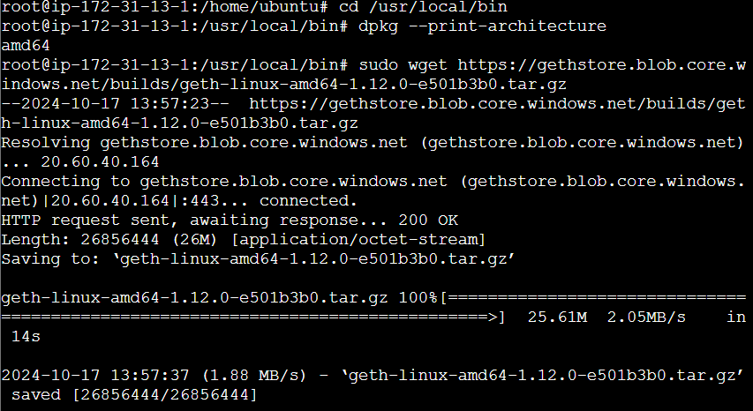

**Step 2: Check the version of geth**

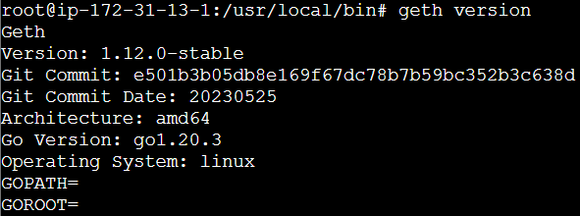

**Step 3: Create a Private Ethereum Network**

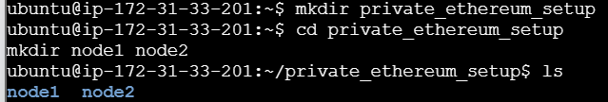

Create 2 nodes

Node 1:

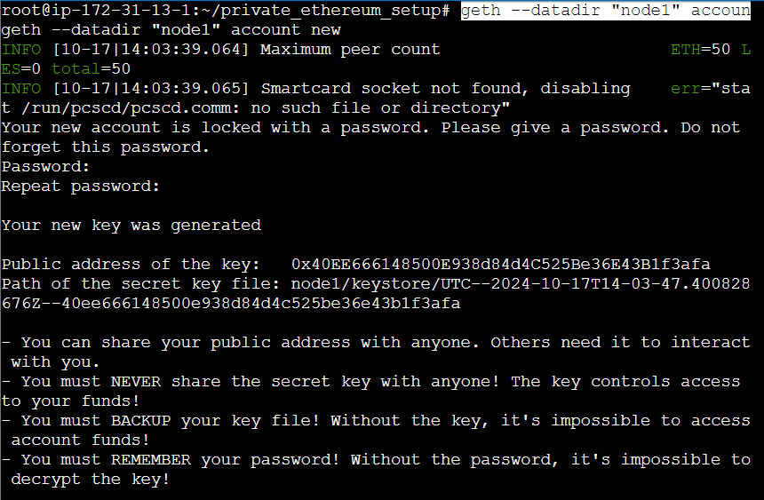

Node 2:

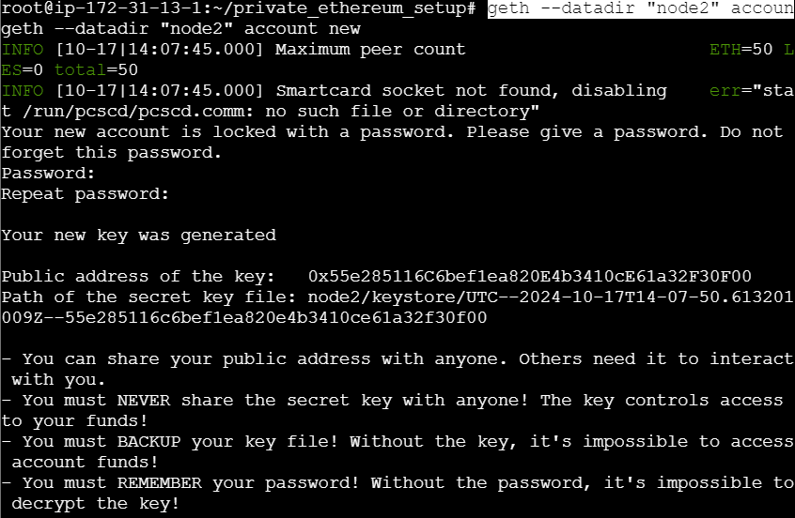



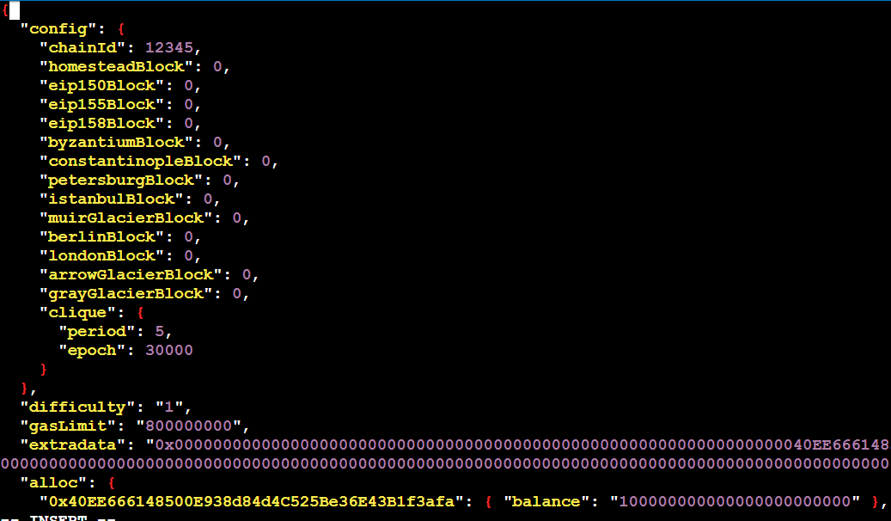

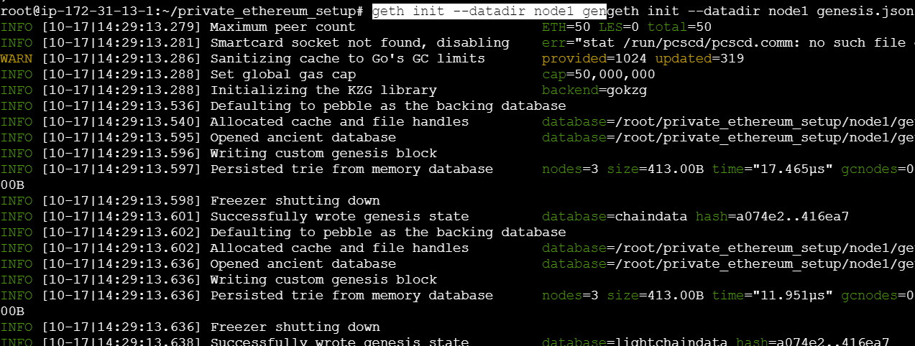

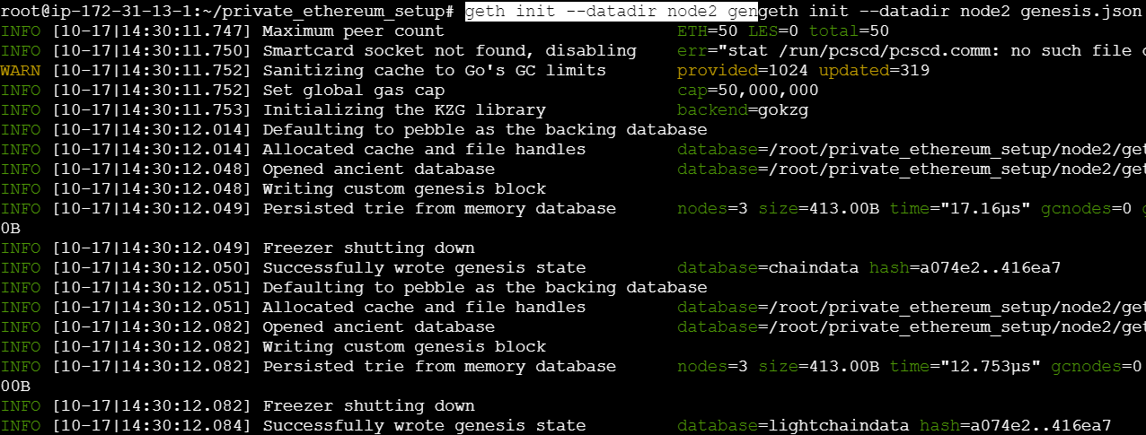

**Configure the bootnode**

sudo add-apt-repository -y ppa:ethereum/ethereum

sudo apt-get update

sudo apt-get install bootnode

**Create a boot.key using**

bootnode -genkey boot.key



**Step 4: Establish a Peer-Peer Connection between the nodes along with the bootnode**

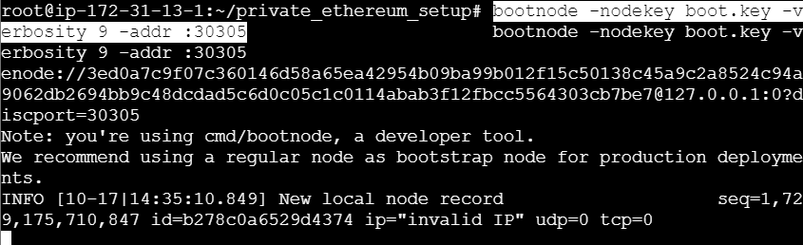

Run the bootnode

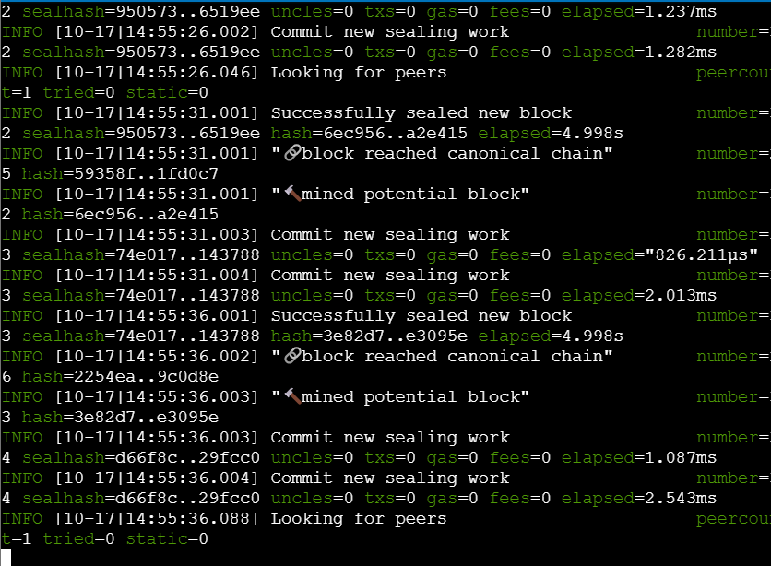

Run node 1 to start mining

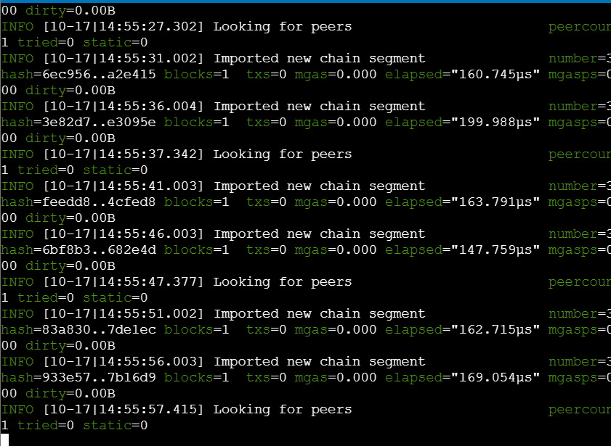

Run node 2, it receives the mined details on its terminal

**Step - 5 : Exploring the network by attaching Javascript console to Node 1**

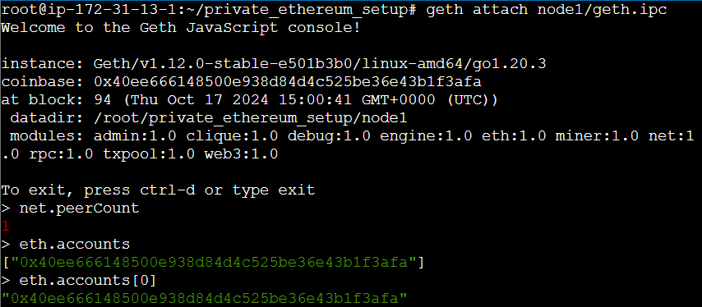

Attach the JavaScript Console with Node 1

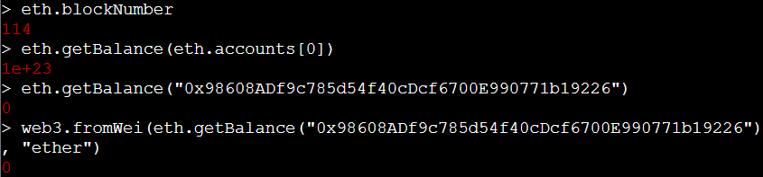

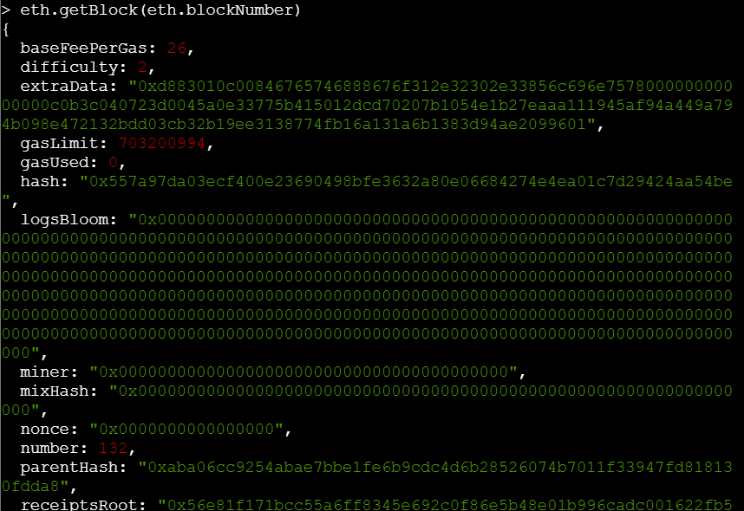

Fetch network status, To list the nodes in the network, To list the nodes in the network , To fetch the number of blocks mined :

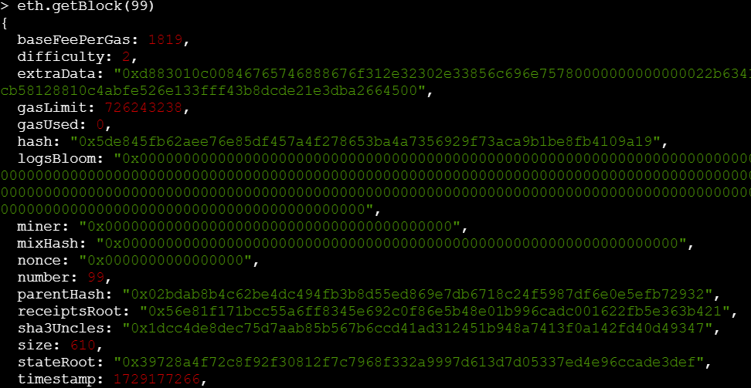

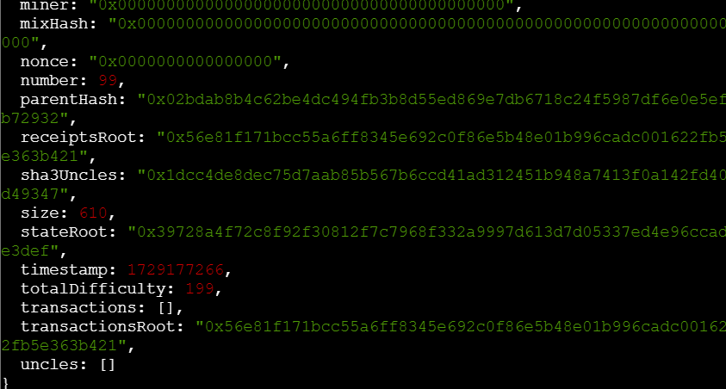

To check the balance of the accounts in wei

eth.sendTransaction({from:"0x40EE666148500E938d84d4C525Be36E43B1f3afa", to:"0x55e285116C6bef1ea820E4b3410cE61a32F30F00", value: web3.toWei(10, "ether"), gas:30000})

web3.fromWei(eth.getBalance("0x55e285116C6bef1ea820E4b3410cE61a32F30F00"), "ether")

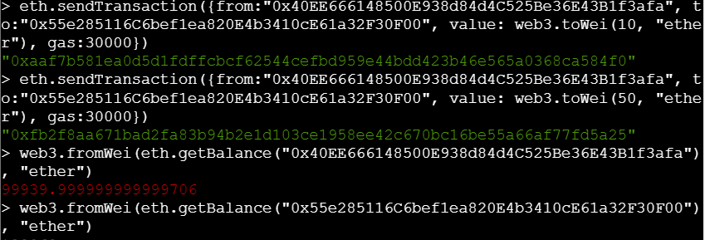

web3.eth.getTransaction("0xfb2f8aa671bad2fa83b94b2e1d103ce1958ee42c670bc16be55a66af77fd5a25")

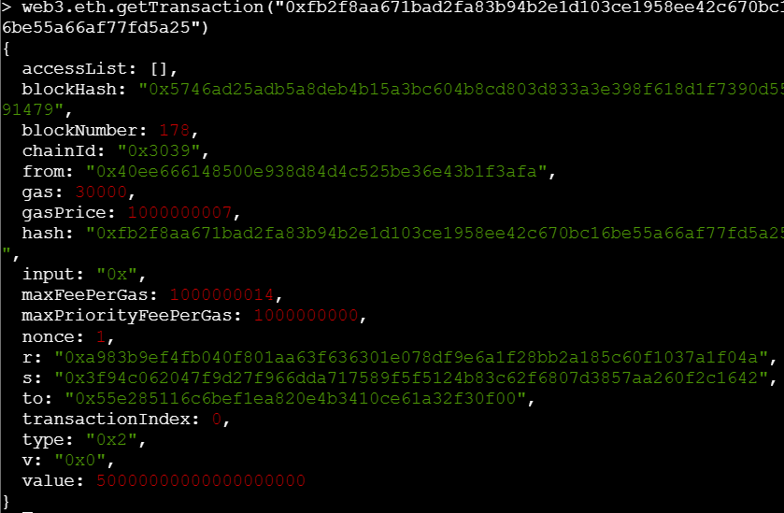

To check the balance of the accounts in ether, get the details of the block in which the transaction is added

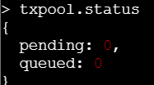

**Conclusion:** Therefore, we studied and understood how to setup a private ethereum network using geth and implemented the same.